The Anniversary Garden

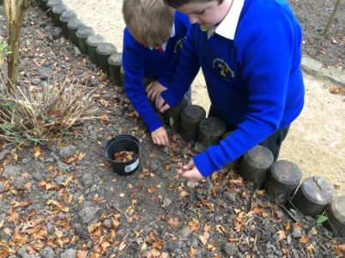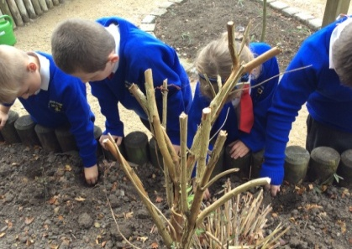
We prepared the ground We made holes in the soil so we could plant the bulbs.
by removing the leaves and
twigs.
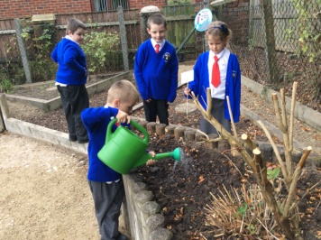

After we had planted the
bulbs we watered them.

We will look after our bulbs throughout the year and see how they change!

Geography
We used atlases, globes and maps to find Australia. We talked about the continent it is on and how we might travel to Australia.

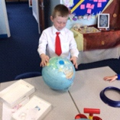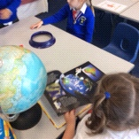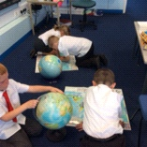
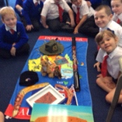

Art

We have been finding out about Aboriginal art. We tried our own ‘dot paintings.’



