
Attendance Matters


St Anne’s Catholic
Primary School

NEW LANCASHIRE COUNTY COUNCIL UPDATES AUGUST 2024

The Department for Education has recently announced National changes to Penalty Notices issued for unauthorised absence in term time.

The changes to be aware of are:

- Penalty notices issued for offences that take place after 19 August 2024 will be charged at a new rate of £160 per parent per child. This can be paid at £80 if paid within 21 days.

- Any second penalty notice issued to the same parent for the same child within a rolling 3-year period will be issued at the rate of £160 to be paid within 28 days with no option for a discounted rate.

- The threshold at which a penalty notice must be considered is set at 10 sessions (equivalent to 5 days) of unauthorised absence within a rolling 10- school week period. This may include absences as a result of arriving late after the register closes. The 10 school weeks may span different terms or school years.

- A maximum of 2 penalty notices may be issued to a parent for the same child within a rolling 3-year period, so at the 3rd (or subsequent) offence(s) another course of action will need to be considered (such as prosecution or one of the other attendance legal interventions).

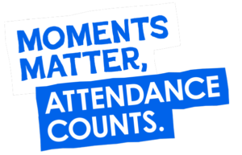
- Only penalty notices issued for absences taking place after 19 August 2024 will count towards the above thresholds.

At St Anne’s Catholic Primary School, we believe that good attendance is crucial to children attaining well, making good progress and reaching their potential.
ATTENDANCE AT
ST ANNE’S

It is vital that your child attends school regularly and arrives at school on time each day.

FACT: Parents have a legal duty to ensure that their child attends school regularly.

Our school target for attendance is 96%

We take school absence very seriously. We closely monitor students whose attendance drops below 96%.

We will contact any family whose child’s attendance drops below 90% which is the persistent absence threshold.
FACT: Children often have social difficulties when they return after an extended absence.

Attendance is linked to Safeguarding; if your child is not in school then we need to check that they are safe and well.

It is important that parents, carers and school, work together to reduce absence and prevent legal action being taken as a result of persistent absence.

FACT: When children are absent, friendships may have moved on and their self-confidence and well-being can be affected.

We have a graduated response that means we will call, text you, send letters, invite you to attendance meetings and may issue Penalty Notices (fines)

The table shows the impact of absences on attendance
FACT: Children with good attendance perform better than those with poor attendance
FACT: Your child misses out on valuable learning when they are absent, which may never be made up.
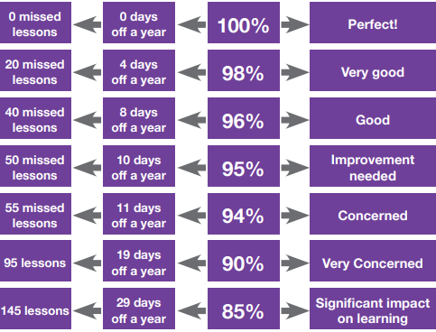

ATTENDANCE AND PARENTAL RESPONSIBILTIES
My child tells me they are unwell, but I am not sure, what should I do?

If your child is too ill to attend school, please contact the school office 01772 422769 or email bursar@st-annes.lancs.ch.uk before 08.45am with full details of your child’s illness/symptoms.

DID YOU KNOW? If we do not hear from you, we will ring you to find out why your child is not in school. If you do not contact us, we will treat the absence as unauthorised.
My child has a doctor’s appointment this morning, so I will keep them off all day, it will not matter…

If you have a medical appointment such as a medical or dental, appointment please try to make these appointment outside of school hours.

DID YOU KNOW? If you are not able to do so, you will be asked to show proof of this.
We really need a holiday, it has been a hard year and it is much cheaper to go in term time!

If your child is feeling ‘a bit under the weather’ then please send them into school.

DID YOU KNOW? If they do not improve, we will contact you to collect them.
My child is struggling to attend school because of a school or home issue so it is best I keep them at home!

Thinking of booking a holiday in term time.

DID YOU KNOW? If you do, from Aug 2024, this will result in a Penalty Notice for each sibling and each adult with Parental Responsibility (PR).

If your child is refusing to come to school because of a school or home issue, you should talk to school as soon a possible.

DID YOU KNOW? We will work with you to overcome the barriers and we expect that you will do everything you can to help your child attend school.
My child has a long-term illness, special educational need or a disability that is affecting their attendance; this is a reason to keep them off school?

If your child has an illness, special education need or a disability, you should talk to school as soon as possible. It is important that you are open and honest and work with your child’s school.

DID YOU KNOW? They have the same right to a suitable full-time education as any other child.

Successfully treating the root causes of absence and removing barriers to attendance, at home, in school or more broadly requires schools and local partners to work collaboratively in partnership with, not against families.
WORKING TOGETHER TO
IMPROVE ATTENDANCE

ALL PARTNERS SHOULD WORK TOGETHER TO: | WHAT SCHOOL WILL DO | WHAT PARENTS CAN DO
Expect  Aspire to high standards of attendance from all pupils and parents  Build a culture where all can, and want to, be in school and ready to learn. | Share attendance data with class teachers and parents  Reward good attendance | Speak positively about school  Prepare children for the school day
Monitor  Use attendance data to identify patterns of poor attendance as soon as possible  Work together to resolve poor attendance before it becomes entrenched. | Inform parents of concerns  Share impact on child’s education, social and emotional well being  Create early intervention opportunities by speaking with parents to identify barriers | Be interested in your child’s attendance – adopt an ‘every day counts’ attitude  Where attendance is a concern - set home targets with your child  Understand the impact on your child’s education, social and emotional well being
Listen and understand  When a pattern is spotted, discuss with pupils and parents, listen to and understand the barriers  Agree how all partners can work together to resolve them. | Demonstrate a partnership  Share impact on child’s education, social and emotional well being  Early intervention - Speak with parents as early as possible  Be attentive and explore what can work for both the family and school | Listen to your child  Help to identify barriers  Early intervention - Speak with staff as early as possible  Understand the impact on your child’s education, social and emotional well being
Facilitate support  Remove barriers in school.  Help pupils and parents to access the support they need to overcome the barriers outside of school.  Offer Early Help Support | Offer in school support  Share impact on child’s education, social and emotional well being  Signpost to services  Make referrals to agencies including charities  Plan together for a shared outcome | Continue working with staff  Engage with the support offered  Be open and honest  Understand the impact on your child’s education, social and emotional well being  Listen, respond and ask questions
Formalise support  Where support is not working or not being engaged with work together to explain the consequences clearly and enable families to respond  If needed formalise support through an attendance contract or education supervision order. | Share impact on child’s education, social and emotional well being  Explain next step and why  Meet with the head teacher and chair of governors to create a plan  Share formal ways of support and how these are monitored and reviewed | Listen, respond and ask questions  Engage with the support offered  Agree and meet the shared targets that are set  Understand the impact on your child’s education, social and emotional well being
Enforce  Where all other avenues have been exhausted and support is not working or not being engaged with, enforce attendance through statutory intervention: a penalty notice in line with the National Framework or prosecution to protect the pupil’s right to an education. | Share impact on child’s education, social and emotional well being  Explain the reasons for the enforcement | Understand the impact on your child’s education, social and emotional well being

We wish to be clear and transparent with you about our policies and procedures so we can work together, striving for excellent attendance and outcomes for all children.

An effective whole school culture of high attendance is underpinned by clear expectations, procedures, and responsibilities.



Our Attendance and Punctuality Policy can be found: https://www.st-annes-lancs.co.uk/attendance/

PLEASE CONTACT US!
Lisa Sumner (Family Support Worker and DSL) 07541 692775 / l.sumner@st-annes.lancs.sch.uk
School office 01772 422769 / bursar@st-annes.lanc.sch.uk

Punctuality Matters

As a school, we are committed to improving punctuality. We are aware that lateness can affect children’s achievement and social relationships and can impact on good routines and habits in preparation for the rest of their lives. Punctuality is a life skill.

DID YOU KNOW?
If you are late, you or your child will be asked why and this will be recorded

We monitor punctuality closely and have strategies in place to address lateness

We track children’s punctuality daily and run reports every week

If your child has 4 or more lates for the half term you will receive letter indicting how many lates and how many minutes of lost learning because of the lates

If your child appears on our weekly report on more than 2 occasions, you will receive a phone call or text

If needed, we can support you with lates

.

It is important to note that from August 2024, lates will be added to your child’s attendance record

We are here to help and support you with your child’s punctuality.
We can meet with you to discuss your child’s punctuality or any concerns you may have.
We can help you with strategies to raise punctuality.
PLEASE CONTACT US!
Lisa Sumner (Family Support Worker and DSL) 07541 692775 / l.sumner@st-annes.lancs.sch.uk
School office 01772 422769 / bursar@st-annes.lanc.sch.uk

ARE YOU ARRIVING ON TIME?


8:45am
You are on time!
The school day begins at 8:45am when the doors to school open.
Your child has arrived in good time to meet friends and get ready for learning.

8:50am
The doors close!
If your child is arriving after this point, you will need to go through the school office and your child will be marked as ‘L’ for arriving late while the register is open.

8:50 – 9.20am
Late arrival!
The registers in class have been taken.
All children have started the first lesson of the day.

9.20am
You are significantly late!
If your child arrives after the registers have closed then they will be marked as ‘U’ for unauthorised late.
This code covers the entire morning session and will affect your child’s attendance record.



THE IMPACT OF BEING LATE

Every Minute Counts!

Missed minutes = Missed learning = Missed opportunities!

DID YOU KNOW?
Lates over a school year can have significant impact on your child’s education.
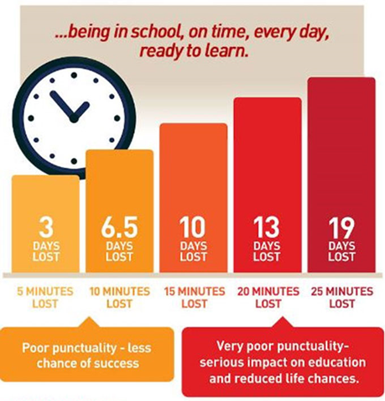

Minutes late add up to days and impacts your child’s attendance!

PUNCTUALITY AND PARENTAL RESPONSIBILTIES
At St Anne’s we expect our parents to support their children with their punctuality. We know that our parents want the best outcomes for their children and we want to support you with this. Look at our TOP TIPS!
ST ANNE’S TOP TIPS!

Small changes can make a big difference!
- Know what time your child is expected in school, plan around this and arrive on time.
- Work with your child to get everything ready the night before e.g. books and uniform.
- Get your child into the habit of doing their homework in the evening – instead of in the morning.
- Make sure your child has a good bedtime routine so they get plenty of rest and don’t struggle to get out of bed in the morning.
- Invest in a good, reliable alarm clock, set it 10 minutes earlier and make setting it part of your child’s bedtime routine.
- Pack your child lunch box the night before.
- Ensure your child has breakfast to set them up for the day.
- Have a back-up plan for getting your child to school in case something crops up – friends or family, perhaps neighbours who are taking their children to school.
- Allow time for your journey – check for any problems with roads or transport.
- If you are finding it difficult to get your child to school on time, talk to a teacher to see how they can help you.
FACT: When your child is late, they miss morning social interactions with their peers
These small changes can help everyone to be ready to leave home in good time, arrive at school punctually and be ready for the day ahead.
FACT: When your child is late, this can cause anxieties
FACT: When coming into the classroom late, this can be embarrassing for your child
FACT: When your child late they can miss a key part of the start of a lesson
FACT: From Aug 2024, Lates will affect your child’s attendance record and can contribute to fine being issued
FACT: Being late can negatively affect your child’s entire day

WORKING TOGETHER TO IMPROVE PUNCTUALITY

Our Attendance and Punctuality Policy can be found: https://www.st-annes-lancs.co.uk/attendance/
Did you know?
We can work with you to assess what your family needs
Did you know?
We can signpost you to other services

Did you know?
We can access external agencies to support you
Did you know?
We can put strategies in place in school to motivate your child

Did you know?
We can visit you in your family home to discuss your concerns

Did you know?
We can put strategies in place in school to motivate your child

But did you know… although we can listen, advise, and action our support… with your help we can achieve!

