St Anne’s Catholic Primary School

EARLY HELP

St Anne's is a family school where we care deeply about the welfare and education of every single child and parent who comes to join us

WHAT IS EARLY HELP?  The term ‘Early Help’ refers to providing support to children, young people, and families as soon as challenges arise, aiming to prevent problems from escalating and improve outcomes before they become more serious.  Every family goes through challenging times at some point. Early help means working with you and your family so that small problems do not become big problems.  Did you know?  - Early Help is for children of all ages and not just the very young.  - Early Help can be very effective in supporting a child, young person and/or their family to step down from statutory services.  - Early Help is important because there is clear evidence that it results in better outcomes for children.  Lancashire County Council recognises that Early Help is a term that describes much of the everyday work of schools.  WHAT IS ST ANNE’S EARLY HELP OFFER?  Lisa, our Family Support Worker, supports our families with day-to-day or long-term challenges. Lisa can work with families to assess their needs and can provide support in various ways such as:  - A listening ear  - Advice and strategies to support challenging behaviour  - Advice and strategies to support attendance or punctuality concerns  - Support in accessing free school meals  - Free uniform  - Access to local food banks / household needs such as furniture  - Signposting for SEND  - Early Help Assessments  - Referrals for parenting support  - Work with other agencies for specialist help – the school nursing team, CAMHS, CANW, NEST  - Details of organisations such as housing, financial or mental health  All of this is underpinned by ensuring that the child is at the center of all we do, and that any support positively impacts upon them.  EARLY HELP IN LANCASHIRE  The vision of all partner organisations working with children and families in Lancashire is to improve children’s lives by working in partnership to raise aspirations, build achievement and protect the most vulnerable.  This is based on the belief that:  - Children, young people and families develop resilience if there are protective factors in place such as: a positive relationship with an adult; good literacy and communication skills; good school attendance; and, parents in or actively seeking/ready for work  - Children’s needs are best met when help is offered in a universal setting within a socially mixed group and early on when problems start to emerge  - Children and young people’s needs are best met when addressed in the context of the whole family, meaning that parents/carers/siblings’ needs are addressed with consent as part of a holistic and integrated Early Help response  Early Help Services should support and strengthen families so that they can thrive. |  |  | 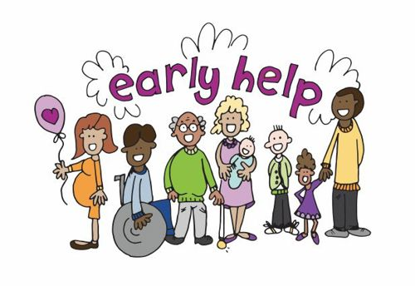
Why would I want early help?
There are many reasons why people look for early help. It could be that you are worried about your child’s health, development or behaviour, or how they are doing at school. It may be that you are worried about money or housing and how that is affecting your family. Maybe your child or family is affected by domestic abuse, drugs, alcohol, or crime. Perhaps your child is a carer for their SEND sibling, or maybe you have had a bereavement in the family that has made life a challenge.



How is Early Help achieved?
Lisa works with our parents and listens to their concerns and challenges. From this, she will discuss and agree a plan with you on how best to support you. For example, ‘a parent is concerned that they are struggling with their child’s behaviour’, from this Lisa can explore what strategies are currently used, what works and what doesn’t, suggest new strategies, refer to parenting courses or make a referral with your consent to other supporting services such as the school nurse. Lisa’s will discuss this with you, so you know and understand what support you are being offered and whether it is suitable for you and your family. To ensure your family will access the correct level of support at the right time, we use the principles set out in the Working Well with Children and Families document. Some families may need an Early Help Assessment.

What is an Early Help Assessment?
The Early Help Assessment is an intervention with a family to gather, explore and analyse with them information about all aspects of the child or young person (and their family’s) life and then to identify areas where change will address support needs and positively impact on their lived experiences. The Early Help Assessment Plan and Review, takes place via Team Around the Family meetings and this is where the wider partnership of services can provide families with the right support at the right time.

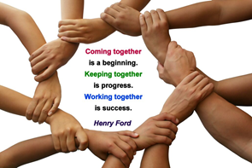

How to access support
Lisa can speak to you via text, telephone, face-to-face, email, home visit or in school. She will listen to your concerns and work with you to support you. Lisa can be contacted via:
Family Support Email: l.sumner@st-annes.lancs.sch.uk
Txt/ Tel: 01772 692775 / 07541 692775
Days: Mon, Tues and half day Wed

Learning Mentor Email: c.pickering@st-annes.lancs.sch.uk
Tel: 01772 692775

Head teacher Email: head@st-annes.lancs.sch.uk
Tel: 01772 692775

ADDITIONAL INFORMATION

Working Well with Children and Families Guidance:
https://www.lancashiresafeguarding.org.uk/media/19299/wwwcf-part-1-and-2-final.pdf

Lancashire CSAP (Children’s Safeguarding Assurance Partnership) website:
https://www.safeguardingpartnership.org.uk/

Lancashire Children and Families
https://www.lancashire.gov.uk/practitioners/supporting-children-and-families/

