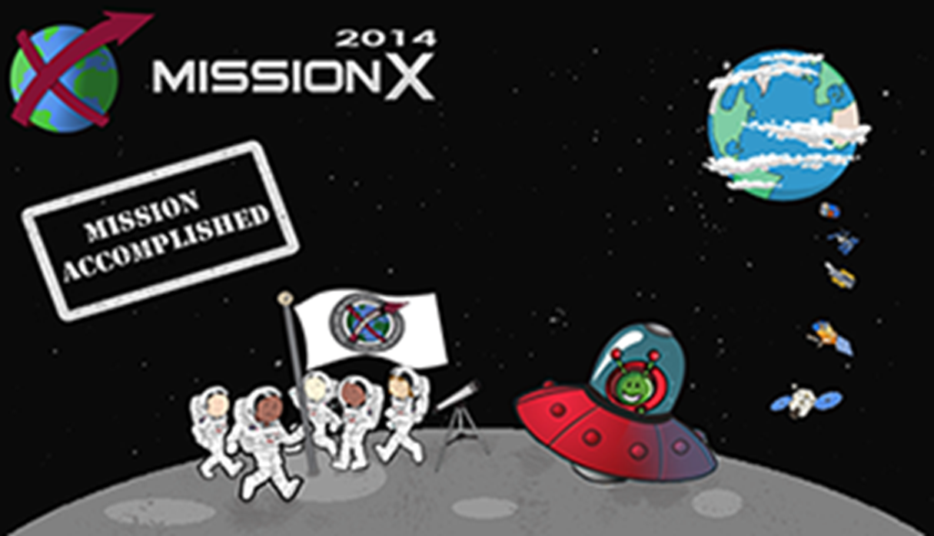

We must leave planet Earth…
You are an explorer who is part of a team which has found a new planet to inhabit.
It is your job to develop a boat to use on the planet, there was no space to transport electrical parts when journeying into space!
Your boat must be wind powered; your research must involve a study of materials which would be best suited to the windy environment of the new planet.

